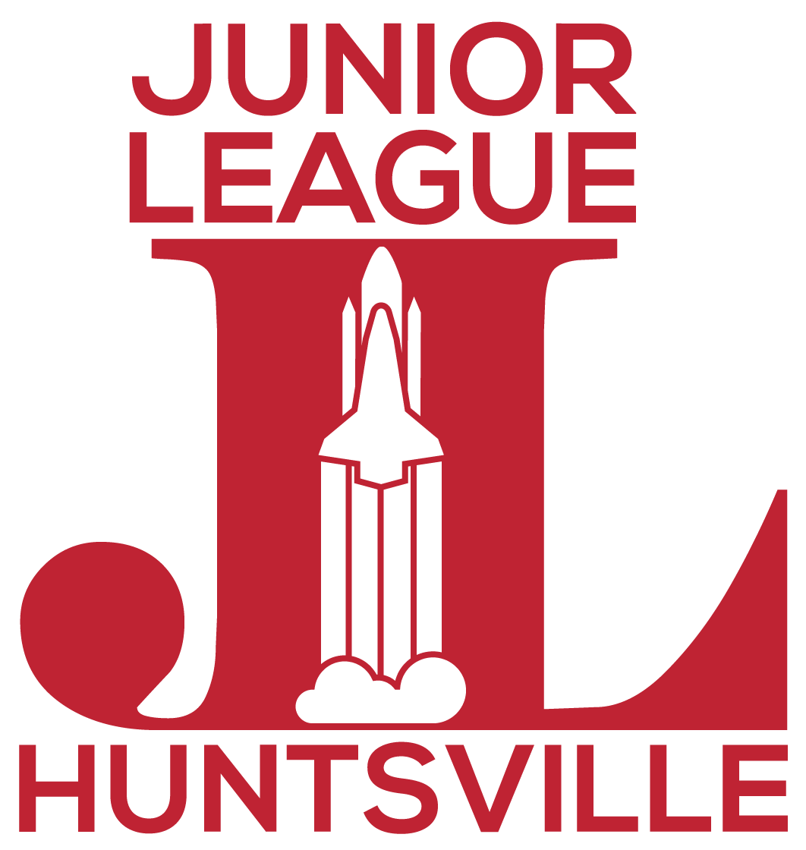

Junior League of Huntsville’s

Project Impact Grant

General Information

Fund Description: Fund established by The Junior League to support Huntsville and its local charities.

Contact Person: Cathryn Schartung-Doud (Chair), Saundra Holden (Co-Chair), and Junior League of Huntsville Project Impact Committee at projectimpact@jlhuntsville.com

Deadline: October 30th 2023 (by 5:00pm)

Areas of Interest: Charitable organizations local to Huntsville/Madison County. Geographic Focus: Madison County, Alabama
Grant Range: $30,000

Areas of Exclusion: Organizations not organized as 501(c)(3) public charities

Debt reduction
Endowment campaigns
Grants to individuals Special events
Annual campaigns Membership drives Conference expenses
Political activities, including education initiatives meant to directly influence political activity

Other Information: Applications are reviewed by the Junior League of Huntsville’s Project Impact Committee. The finalists selected will be presented to the JLH’s Membership. JLH Members will vote for the finalist of their choice. The finalist with the plurality of the votes will receive the Project Impact grant. Please contact the Junior League of Huntsville Project Impact Committee at projectimpact@jlhuntsville.com to discuss questions about the application process.

Grant Cycles: Project Impact grants will be awarded on an annual basis.

Instructions: Please read the grant guidelines and application instructions in their entirety before you begin an application. Submit completed grant application by 5 p.m. on the application deadline to projectimpact@jlhuntsville.com

Project Impact

Application Information

Organization Name
Tax ID Number
Address
Telephone
Website
Executive Officer Name
Position title
E-Mail Address
Telephone
Person Completing Application
Position title
E-Mail Address
Telephone

Project Impact
Grant Proposal
Please submit a written Grant Proposal that addresses the following questions:
- Organization Mission Statement
What is your organization's board-approved mission statement? (100 word maximum)

- Organization's Primary Focus

- Project Title
Please provide a brief, descriptive name of the project.

- Amount Requested
- Project Summary
Please summarize your proposal and how it will benefit Huntsville/Madison County. (75 word maximum)

- Project Description
Please describe in detail the proposed project including the scope of activities and the intended impact on clients. (250 word maximum)

- Community Need Description
What need does your project address? Please provide details demonstrating that this is a community need such as census data, community assessments/surveys, independent studies, etc. (150 word maximum)

- Who will be served by this project?
Please describe those who will be impacted by this project. (150 word maximum)

- Staff Summary
What are the names and titles of staff and/or volunteers who will have the greatest responsibility for implementing the proposed project? What skills and experience do they bring to this project? (150 word maximum)

- Project Partners
Will you partner with another organization/other organizations for this project? Please name the agencies and describe the role they will play, including monetary or in-kind support. (150 word maximum)

- Project Differentiation
What void will your project fill? What sets your project apart from other organizations currently addressing this need? (150 word maximum)

- Project Duration
If approved, when would you begin using funds for this project? When do you anticipate completing this project? What key milestones will verify that the program is on track to achieve its intended results? (150 word maximum)

- Proposed Results
What results will this project achieve and how will you measure these results? (150 word maximum)

- Project Sustainability
If selected for funding, how will your organization sustain the project beyond this funding? (150 word maximum)

- Project Challenges
Describe any challenges you will face to achieve the intended results. How will you overcome these challenges? (150 word maximum)

