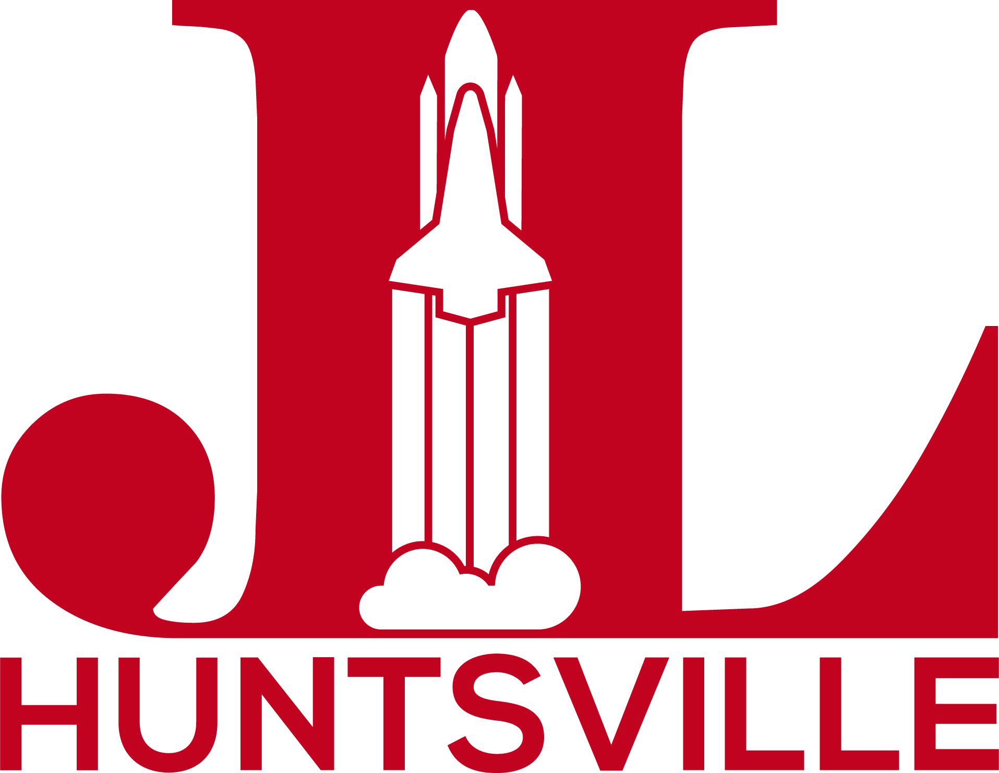

Mission Statement: The Junior League of Huntsville is an organization of women committed to promoting voluntarism, developing the potential of women, and improving communities through the effective action and leadership of trained volunteers. Our purpose is exclusively educational and charitable.

The Junior League of Huntsville (JLH) is pleased to offer requests for assistance from local, non-profit organizations that are striving to improve our community; especially in our current impact area of Improving Family Literacy. The JLH Board of Directors reviews grant applications each year and then makes a recommendation to supply funding and/or volunteers based on alignment with our mission and impact area, interests of our members, and our available resources. This recommendation is then voted on by our members. This year’s Community Grant recipients will be announced at our Spring Fundraiser, The Book Ball, on April 9, 2022. The program period for this grant and any volunteers is July 1, 2022–June 30, 2023.

Each year JLH members choose a placement within the League and many of our members choose to serve on committees that work directly with our Community Partners and focus on specific community projects. In general, our volunteers participate in projects beginning in June and ending the following May to correspond with the JLH fiscal year. The JLH is often able to provide 3–10 volunteers per placement, which includes a Chair for the specific community project. JLH members typically spend 20–40 hours annually on their placement. A majority of our members are working professionals who need flexible opportunities including weekend and evening hours. Daytime volunteering opportunities are also considered based on the availability of our members.

Upon completion of your application, JLH will send an acknowledgment of receipt. Organizations currently contracted with JLH must reapply for funding for projects beginning in 2022. Funds will be disbursed to selected partner agencies by May 2022 and new placements for volunteers will commence on or after July 2022. Please contact JLH with any questions at info@jlhuntsville.com.

Junior League of Huntsville
2022-2023 Community Grant Application

JLH will accept applications that are fully completed and submitted to the JLH by 5:00 PM on February 25, 2022, via email, and include the signature of the agency’s Executive Director or President of the Board of Directors. A community partner may receive volunteers only or may receive a combination of volunteers and funding based on the needs of the specific program and the goals of JLH relative to the program. Selected applicants must execute a contract with JLH by June 2022, and must permit on-site visits by JLH representatives.

Eligibility Requirements
- Applicant must maintain tax-exempt nonprofit status as approved by the IRS.
- Applicant must submit a copy of its latest financial audit and annual report with the grant request.
- Community programs must fall within the current JLH Impact Area of Improving Family Literacy. The JLH focuses on all aspects of literacy including but not limited to reading, writing, comprehension, technological, financial, digital, global, nutritional, and civic literacy. We hope to partner with programs that improve the lives of the citizens of Madison County through literacy. Programs outside this Impact Area will not be considered at this time.
- The request must be submitted on the JLH Partnership Grant Application form provided and returned with all required signatures and documents. The application is available in both hard copy and electronic format.
- Programs must benefit residents of Madison County.

Not eligible
- Religious, political, or medical research projects or programs
- Funds used for travel budgets or providing transportation
- Fundraising drives, capital campaigns, building funds
- Research projects
- Renovations for buildings not owned or in a long-term lease

Applicants must include the following documents with the application
- Completed original application
- Current list of the agency’s Board of Directors
- List of partner organizations
- Most recent letter of IRS Determination of Tax-Exempt Status
- Audited Financials or Agency’s year-end balance sheet, Statement of Activity and Budget to Actual or other financial documents (if not available, please explain)
- Copy of General Liability Coverage or letter of confirmation from insurance agency

Junior League of Huntsville
2022-2023 Community Grant Application

Name of Agency
Executive Director
Year Organized
Tax I.D. Number
Contact Person
Title
Contact E-mail
Organization Address
Contact Telephone
Website Address
Total Number of Volunteers Requested
Total Amount of Funds Requested
Program Start Date

Signature of Executive Director and President of Board of Directors
(Signatures are mandatory)

__________________________ __________________________ Signature Signature

Printed Name: Printed Name:
Title: Title:
Date: Date:
Junior League of Huntsville
2022-2023 Community Grant Application

- Your Organization
  - What is the purpose and mission of your organization? (500-word limit)

  - Number of full-time employees:
Number of part-time employees:
Number of volunteers:

- Specific Program Request
  - In 500 words or less please describe the specific program for which you are requesting support. Please include the program’s purpose, goals, and objectives.
  - What community needs does your program meet and how many people do you anticipate serving each year?
  - How will you measure the effectiveness of this program?
  - Please list any other organizations/agencies you will collaborate with on this program.
  - Are you seeking funding, volunteers, or both?
    - If you are seeking JLH volunteers, please describe in detail the volunteer’s duties and time commitment as well as any necessary training or requirements for volunteers. Also, what skills would this placement enhance or cultivate for our volunteers?

- Funding Request and Financial Overview
  - What is the total program budget?
  - What amount of funding are you requesting from the JLH?
  - Please specify how JLH funds would be used.

- JLH Partnership Commitment
  - Would your organization be willing to sign a letter of understanding with JLH outlining volunteer arrangements and expectations, link to JLH on your organization’s website, allow the JLH website to list you as an agency partner and link to your website, allow an opportunity for the JLH logo to be included in printed and online materials related to the project, and allow JLH to be recognized in any publicity related to the project? (highlight one)
YES NO

- Is there anything else you would like for us to know about your organization and/or the specific program for which you are seeking support? (500-word limit)

Email completed proposal package plus all required attachments to info@jlhuntsville.com.

ALL APPLICATIONS FOR 2022-2023 GRANTS MUST BE RECEIVED BY 5:00 PM ON FEBRUARY 25, 2022

